Programming and Mathematics for Artificial Intelligence IN3063

Group 5 (Zi Hen Lin, Saif Ahmed, Khyber Jan, Ernest Memishi)
https://github.com/ZH0555/PMAI-Group-5

Task 1

1a)
The dataset chosen for this task was the CIFAR-10, which consists of 60,000 32x32 colour images across 10 different classes. The reasoning behind this choice was because the dataset is complex enough and proves a challenging problem for developing and evaluating neural network models on image data. Allowing us to demonstrate the ability to handle multi class classification while managing the complexities linked with colour images and small image sizes. Making it a suitable dataset for balancing feasibility and complexity.

1b)
Activation functions like Sigmoid and ReLU introduce non-linearity in the neural network, which allows it to learn complex patterns. Both functions allow for forward and backward pass, the forward pass computes the activation, and the backward propagation calculates the backward propagation.
Activation | Formula | Range | Pros | Cons
Sigmoid | 1/ (1+e^(-x)) | (0,1) | Output is bounded from (0,1), preventing extremely large activations. | Neurons can saturate, meaning they become nearly untrainable
ReLU | Max(0,x) | [0, ∞) | Avoids vanishing gradients (for positive inputs), and allows for much faster training | Dying ReLU problem. If gradient is 0, then neuron ‘dies’
Leaky ReLU | F(x) =  | x if x > 0,  |⍺x if x ≤ 0 | (-∞,∞) | Solves the main ‘dying ReLU’ problem by allowing a smaller gradient for negative inputs, which prevents neurons from becoming inactive which can lead to improved learning in networks | Must choose a smaller slope (i.e. 0.01), which leads to another parameter to tune and a poor choice of the slope can hurt performance. (Extra parameter also)

1c)
The softmax activation function is a way to maintain numerical stability. The forward pass calculation can be represented by the equation:
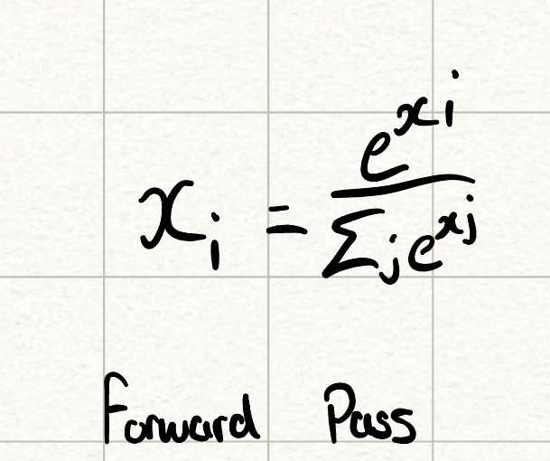
And this forward pass method computes on the input logics (x) in this example, and converst them into a probability distribution. To maintain the numerical stability and prevent overflow, when calculating e^xi for larger inputs, the implementation subtracts the maximum value from all inputs before the exponent, ensuring that numbers aren’t too large.
i.e. assuming that x is a single vector, we can use the log-sum-exp trick to prevent underflow:
exp^x = np.exp(x – np.max(x))
The backwards pass calculates the gradient of the function, typically given by dx:
Dx = self.y_pred * (d_out – elementSum)
Where
elementSum = np.sum(d_out* self.y_pred, axis = 1, keepdims = True).
Noting that this is for vectors and also covers for a single unit of data.

1d)
The goal of inverted dropout is to ensure that the NN’s forward pass remains unchanged and efficient during test time, and outputs are scaled by 1/p where p is the keep probability. And p = 1 – d, where d is the drop out rate (probability that a neuron is set to 0 during training).
When 1-p neurons are dropped, the total output of the layer is decreased by p. If this is not compensated, then the activation magnitudes will be p times greater (unstable). Thus, multiplying by 1/p scales the expected and actual output (x) is consistent. The equation is shown by the input activation multiplied by the dropout mask M, and there is an element wise multiplication (Hadamard product).
For backwards pass, the gradient is multiplied by the same factor (1/p) and same dropout mask M.

1e)
The neural network

